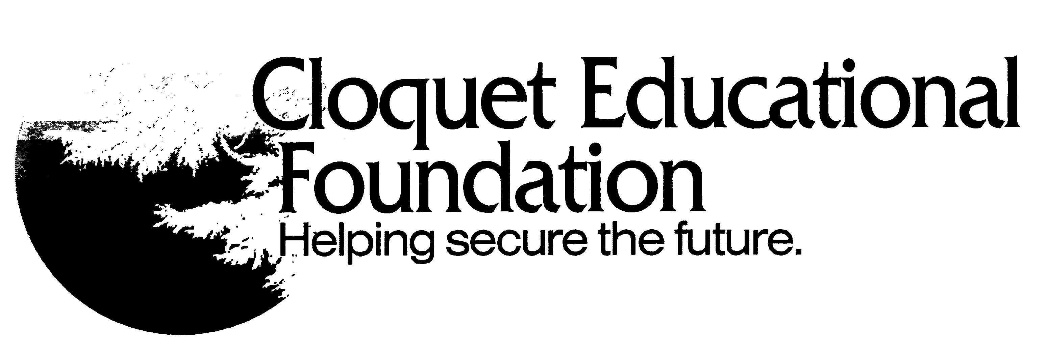 | Cloquet Educational Foundation  Grant Application Form
Primary Applicant Name | Grade/Subject/Department |  | School |  | Email Address
Additional Applicant Names |  | Grade & Subject Currently Teaching |  | School
Signature of Principal/Supervisor:

In signing this application, I am certifying that this proposed project would be a good use of funds for our school or department.

Title of Project: ______________________________________ Date: ____________________________

Total Amount Requested: __________ Make Check Payable To: ______________________________________

Brief Project Summary: Include a description of the project (Limit your response to 200 words or less)
Number of students served: (i.e. 100 5th grade students or 45 CHS Art students)

This Project Is:
□ A new innovative grant project
□ A request to continue a project that was previously awarded CEF funding support (if you check this, be sure
to explain in your Project Description why you feel your program/activity deserves to be funded again).

Location of Project:  □ Cloquet High School  □ Cloquet Middle School  □ CAAEP  □ Churchill Elementary School*  □ Washington Elementary School*  □ Submitting a joint proposal was declined* (please explain on page  three, budget box #1).  *If your application is from one of Cloquet’s public elementary schools, a contact is required to be made to the other building’s staff about the possibility of submitting a joint proposal | For Office Use:  APPLICATION Letter ______  Previous CEF Funds Awarded:  Amount:  Date:

Project Description

- Provide a thorough description of the project and the need it addresses. How does this project align with the CEF mission: Cloquet Educational Foundation provides opportunities for academic, artistic, athletic, cultural and social growth for children and youth in the Cloquet area by financially supporting programs and activities. Explain the duration of your project (i.e. two weeks, one year) and if available, data to support your project. (Limit your response to 200 words or less.)
- Specifically, how will your project improve, advance, or enrich student learning? (Limit your response to 100 words or less.)
- How does this project support at least one of the District Priorities:
- “plan/provide first-rate technology & access to technology for our students & community”
- “continue to promote understanding and appreciation of cultural & socioeconomic diversity”
- “emphasize high standards/expectations & improve social behaviors”
(Limit your response to 100 words or less.)

Budget
Include in the budget lines below, items that the CEF grant funds will pay for and the cost of each item.
(example: 50 nonfiction books for the CMS Media Center, Cost $750 ($15 x 50 books)
Item | Cost
Total Cost

- Submitting a joint proposal between elementary schools was declined □ Yes □ No If yes, explain here):

- Describe why your requested amount is justified in regard to impact and / or the number of student participants: (Limit your response to 100 words or less.)

- Can this project be implemented with partial funding: □ Yes □ No If yes, explain here:

- Have you requested funding from other sources for this project? □ Yes □ No

- If yes, please list the names of the funding sources and the status of the request:

The CEF Board of Directors reserves the right to select or reject any or all proposals. By submitting this application, if you are selected for an award, you agree to do the following:

- Submit a final report describing your project and its benefits by the deadline indicated.
- Submit at least two pictures of your project electronically, for use in promoting CEF grants.
- Publicly recognize the Cloquet Educational Foundation as a financial supporter of this project.
- Provide us with student written letters of appreciation from those who were served by this grant (these letters are sent to donors with the formal thank you letter from CEF).

Please send your completed form by the deadline date to: Cloquet Educational Foundation, 302 14th Street, Cloquet, MN 55720, Fax: (218) 879-6724. If you have questions, please call (218) 879-3806.

